**DELHI TECHNOLOGICAL UNIVERSITY**



**DATABASE MANAGEMENT SYSTEM**

**PRACTICAL FILE**

**Submitted to: Submitted by:**

Dr. Shailender Kumar Kunal Sinha

Associate Professor 2K17/CO/A3/164

**INDEX**

|  |  |  |  |  |
| --- | --- | --- | --- | --- |
| **S.No** | **Experiment** | **Done On** | **Checked on** | **Signature** |
|  |  |  |  |  |
|  |  |  |  |  |
|  |  |  |  |  |
|  |  |  |  |  |
|  |  |  |  |  |
|  |  |  |  |  |
|  |  |  |  |  |
|  |  |  |  |  |
|  |  |  |  |  |
|  |  |  |  |  |
|  |  |  |  |  |
|  |  |  |  |  |
|  |  |  |  |  |
|  |  |  |  |  |
|  |  |  |  |  |

PROGRAM 1

**AIM:**

1. Creation of a database and writing SQL Queries to retrieve information from the Database.
2. To implement Data Definition Language (DDL)
   1. Create, Alter, Drop, Truncate.
   2. To implement constraints
      1. Primary Key
      2. Check
      3. Unique
      4. Not Null
      5. Default

**THEORY:**

1. **CREATE TABLE:** The Create Table statement is used to create a new table in database.



1. **ALTER TABLE:** The ALTER table statement is used to add ,delete or modify columns in an existing table.

It is also used to add and drop various constraints on existing table.



1. **DROP TABLE:** The DROP table command is used to remove a table definition and all data ,indexes ,triggers, constraints and permission specifications for that table.



1. **TRUNCATE:** This command is used to delete complete data from an existing table



1. **COLUMN CONSTRAINTS:** SQL constraints are used to specify therules for data in a table.

Constraints are used to limit the type of data that can go into a table. This ensures the accuracy and reliability of the data in the table. If there is any violation between the constraint and data action, the action is aborted.

Constraints can be column level or table level. Column level constraints apply to a column, and table level constraints apply to the whole table.

The following constraints are commonly used in SQL.

* **PRIMARY KEY:** A combination of NOT NULL and UNIQUE. Uniquely defines each row in a tuple.
* **CHECK:** Ensures that all values in a column satisfies a specific condition.
* **UNIQUE:** Ensures that all values in a column are different.
* **NOTNULL:** Ensures that a column cannot have a NULL value
* **DEFAULT:** sets a default value for a column when no value is specified.

# **DEPARTMENT**

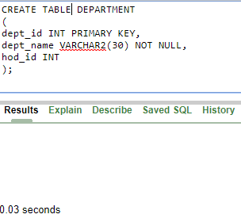

1. **DOCTOR**

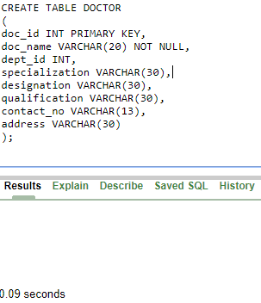

1. **NURSE**

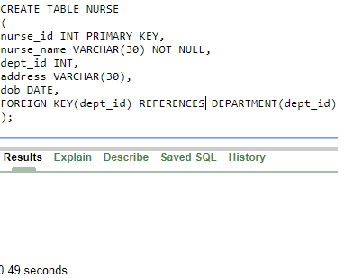

1. **TEST**

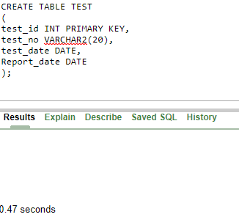

# **WARD**

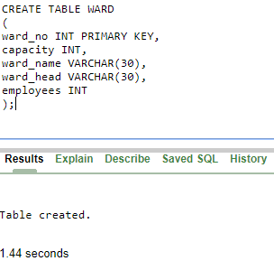

* **Alter Table Command**

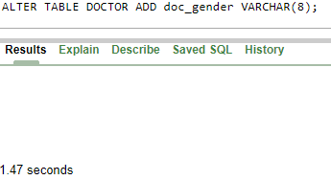

* **Truncate Table Command**

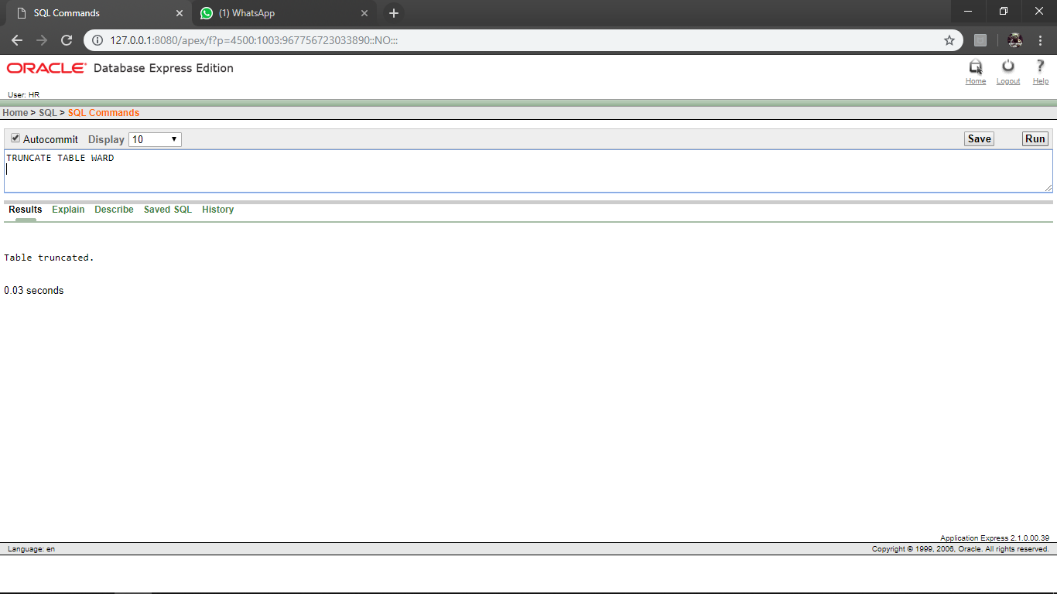

* **Drop Table Command**

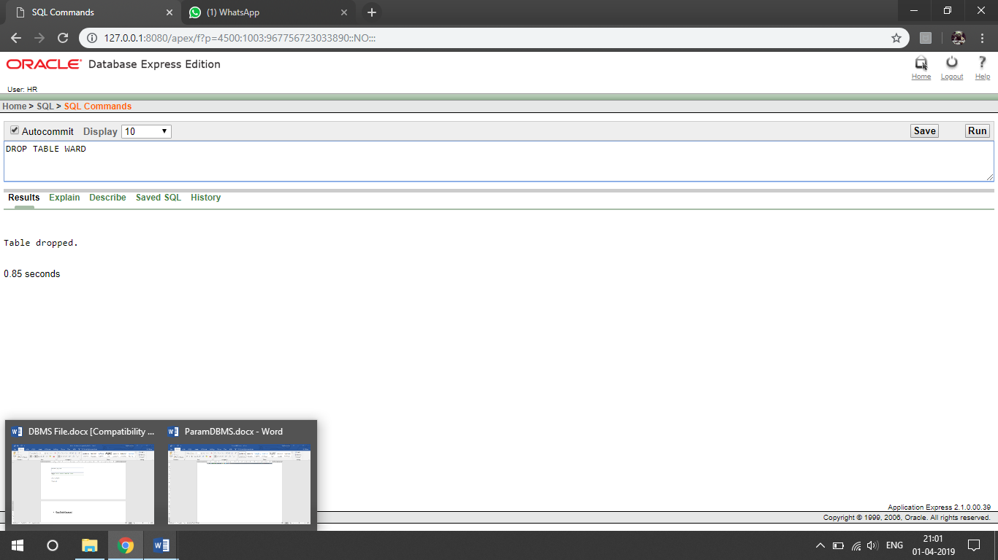

**FINDINGS/LEARNING:**

1. The **CREATE** table defines the Schema of the table **DOCTOR, DEPARTMENT, NURSE, WARD** and **TEST**.
2. The **ALTER TABLE** command adds another column to the DOCTOR table.
3. **DROP TABLE** command deletes the schema of the table WARD.
4. **TRUNCATE** command deletes all the entities in the table WARD

**DISCUSSION:**

We get to run DDL queries for creation of database, alter, truncate the records and drop to physically remove the schema from the database.

**CONCLUSION:**

The Hospital Management system is created and DDL queries are successfully executed on it.

**PROGRAM 2**

**AIM:** To implement Data Manipulation Language (DML)

* 1. **INSERT**
  2. **SELECT**
  3. **DELETE**
  4. **UPDATE**.

**THEORY:**

1. **INSERT:** The Insert statement is used to insert data into table.



1. **SELECT:** The Select statement is used to retrieve data from table



1. **DELETE:** The Delete statement is used to delete records from database table.



1. **UPDATE:** The Update statement is used to update data in an existing table.



* **INSERT**

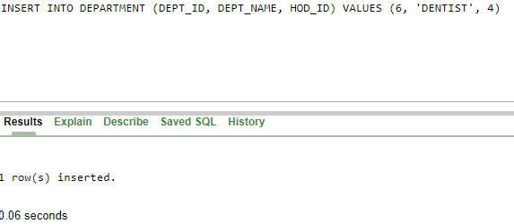

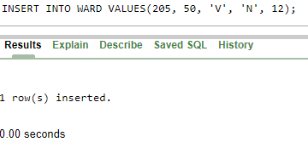

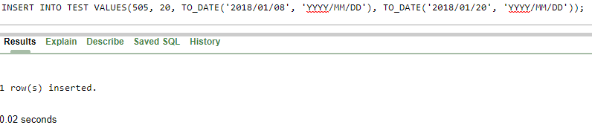

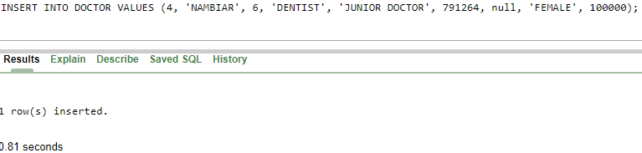

* **SELECT**

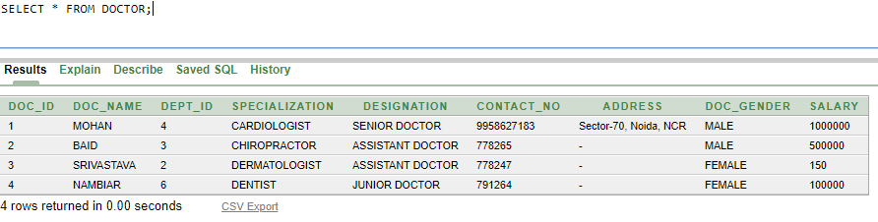

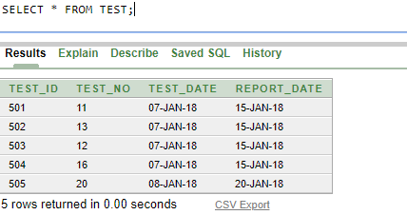

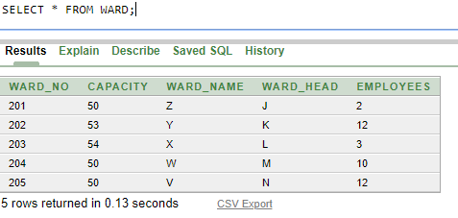

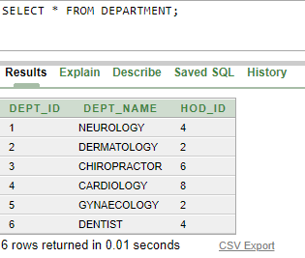

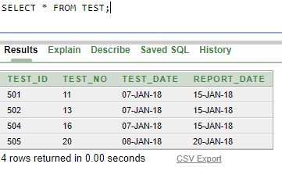

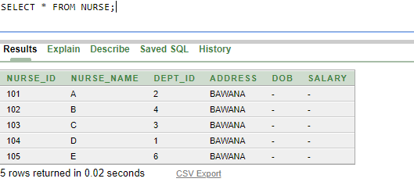

* **UPDATE**

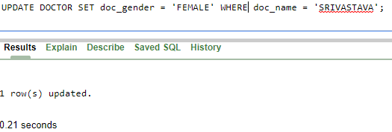

* **DELETE**

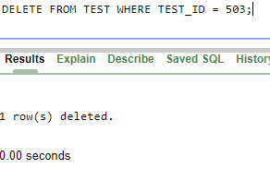

**FINDINGS/LEARNING:**

1. The **INSERT** command is used to insert values in **DOCTOR, DEPARTMENT, NURSE, WARD** and **TEST**.
2. The **SELECT** command retrieves data from tables DOCTOR, DEPARTMENT, NURSE, WARD and TEST.
3. The **DELETE** command deletes the records from **TEST** where **TEST_ID=503**.
4. The **UPDATE** command updates the **DOCTOR** table and sets **DOC_GENDER=’FEMALE’** where **DOC_NAME=’SRIVASTAVA’**.

**DISCUSSION:**

The DML queries facilitate manipulations on the created database by inserting, selecting, deleting and updating the entries in various schemas of the Database .

**CONCLUSION:**

The DML queries are successfully executed on The Hospital Management system.

**PROGRAM 3**

**AIM:** To implement Aggregate functions in SQL

* + - AVG( )
    - COUNT( )
    - MIN( )
    - MAX( )
    - SUM( )

**THEORY:**

SQL Aggregate functions return a single value calculated from the values in column.

|  |  |
| --- | --- |
| **Function** | **Description** |
| AVG( ) | Returns the average value |
| COUNT( ) | Returns the number of rows |
| MAX( ) | Returns the largest value |
| MIN( ) | Returns the smallest value |
| SUM( ) | Returns the sum |

* **AVERAGE**

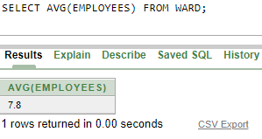

* **COUNT**

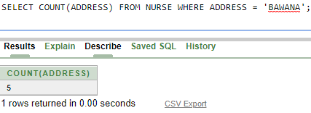

* **SUM**

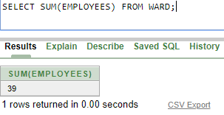

* **MAX**

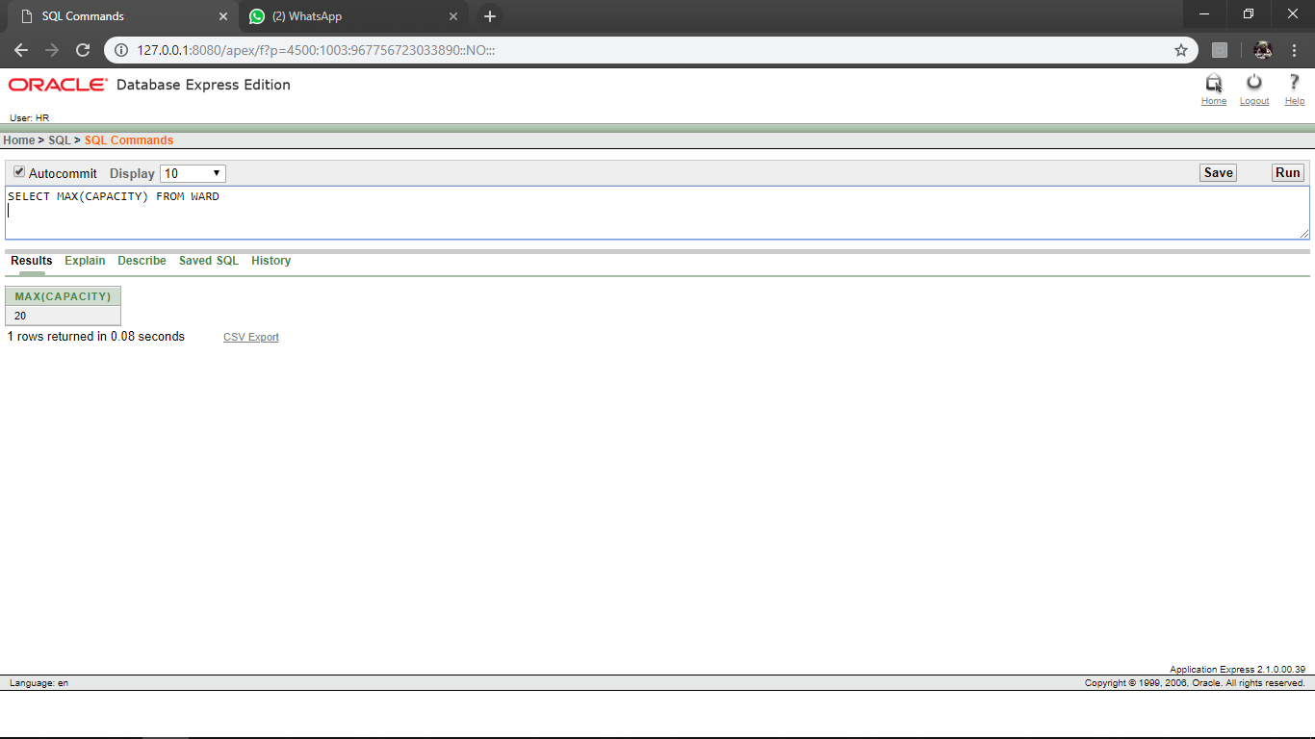

* **MIN**

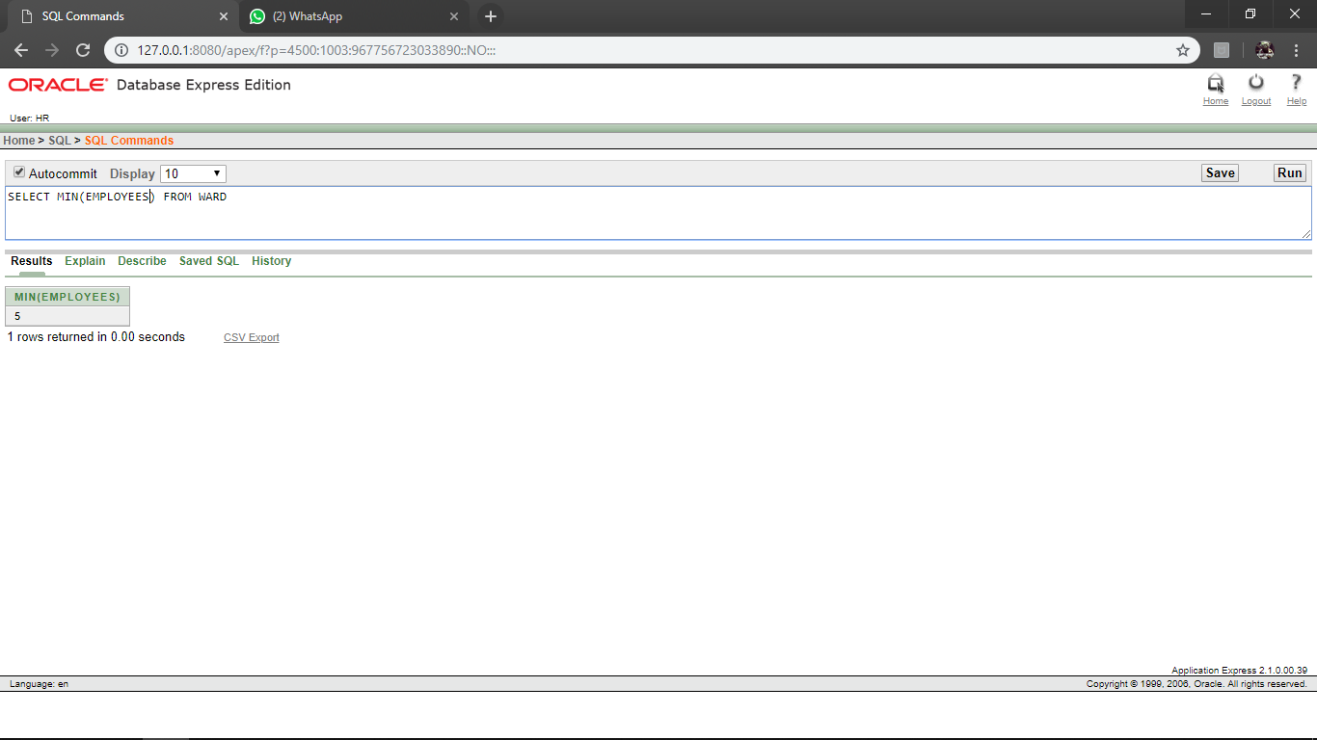

**FINDINGS/LEARNING:**

* The Aggregate functions MAX( ), MIN( ), SUM( ), AVG( ) and COUNT( ) are used to perform calculations on the tables **DOCTOR, DEPARTMENT, NURSE, WARD** and **TEST**.

**CONCLUSION:**

The Aggregate functions are successfully executed on The Hospital Management system.

**PROGRAM 4**

**AIM:** To implement the following functions in SQL

* + - String Functions
    - Date Functions

**THEORY:**

**String Functions:** SQL string functions return a single value calculated from the values in column.

|  |  |
| --- | --- |
| **Function** | **Description** |
| LEN( )/LENGTH() | Returns the length of value in the text field |
| LOWER( )/LCASE() | Converts character data to lower case |
| SUBSTRING( ) | Extract characters from a text field |
| CONCAT( ) | Add two or more strings together |
| UPPER( )/UCASE() | Converts character data to upper case |

**Date Functions :** SQL date functions are used to find current date and time from system

* **LENGTH**

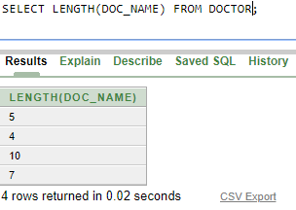

* **CONCAT**

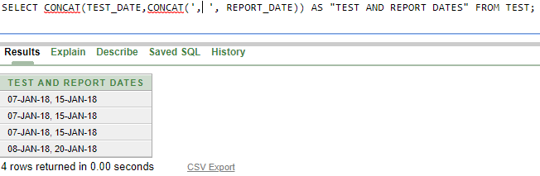

* **LOWER**

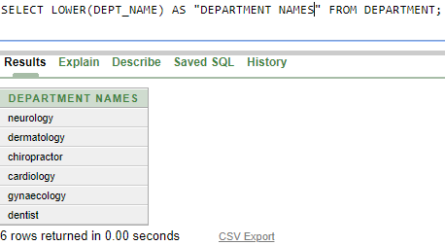

* **SUBSTRING**

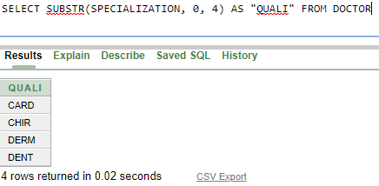

* **UPPER**

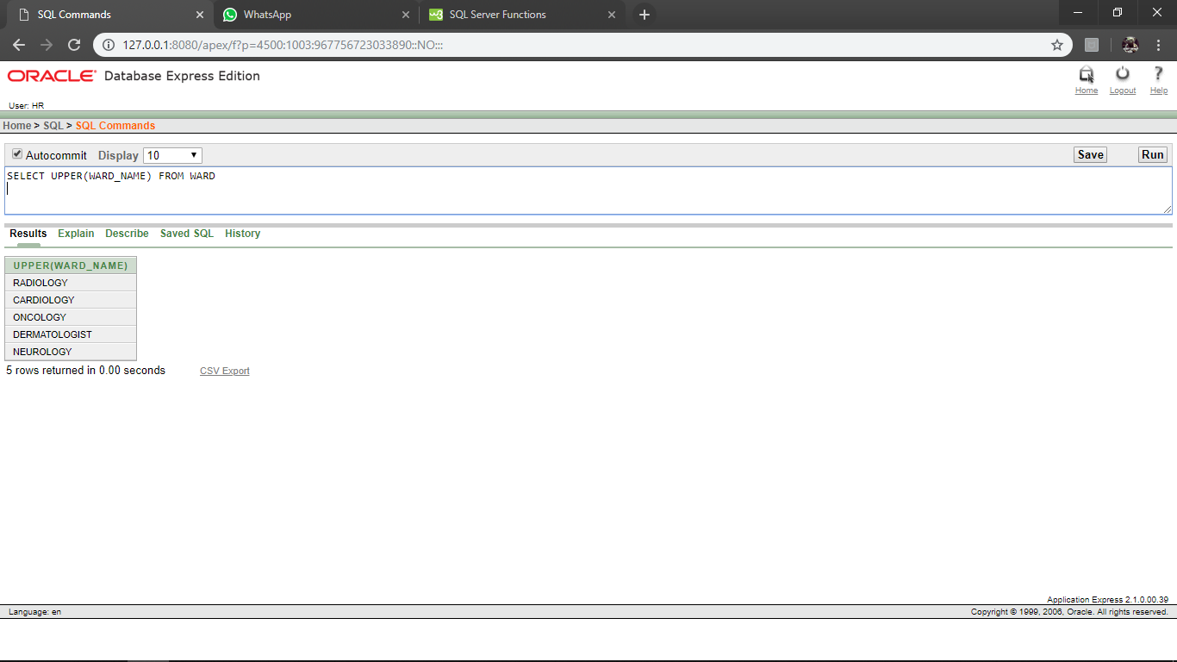

**DATE FUNCTIONS**

* **SYSTEM DATE**

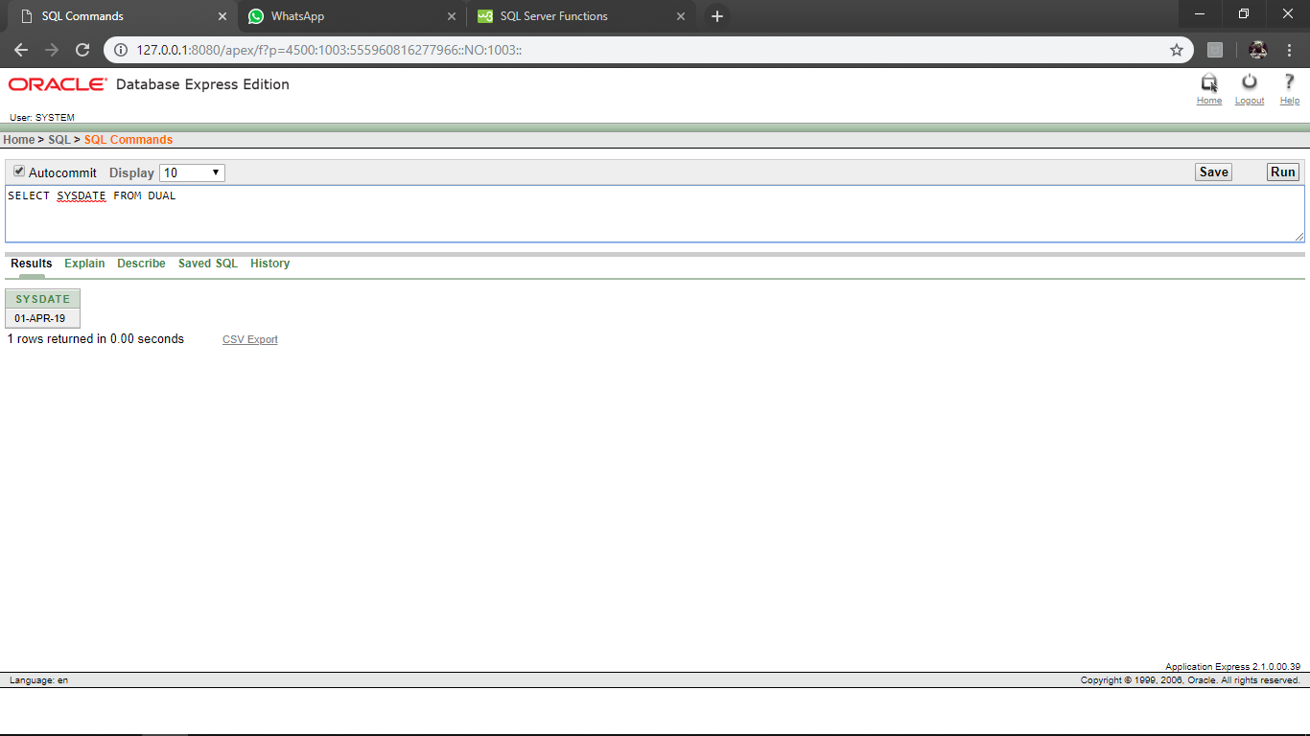

* **SYSTEM DATE AND TIME**

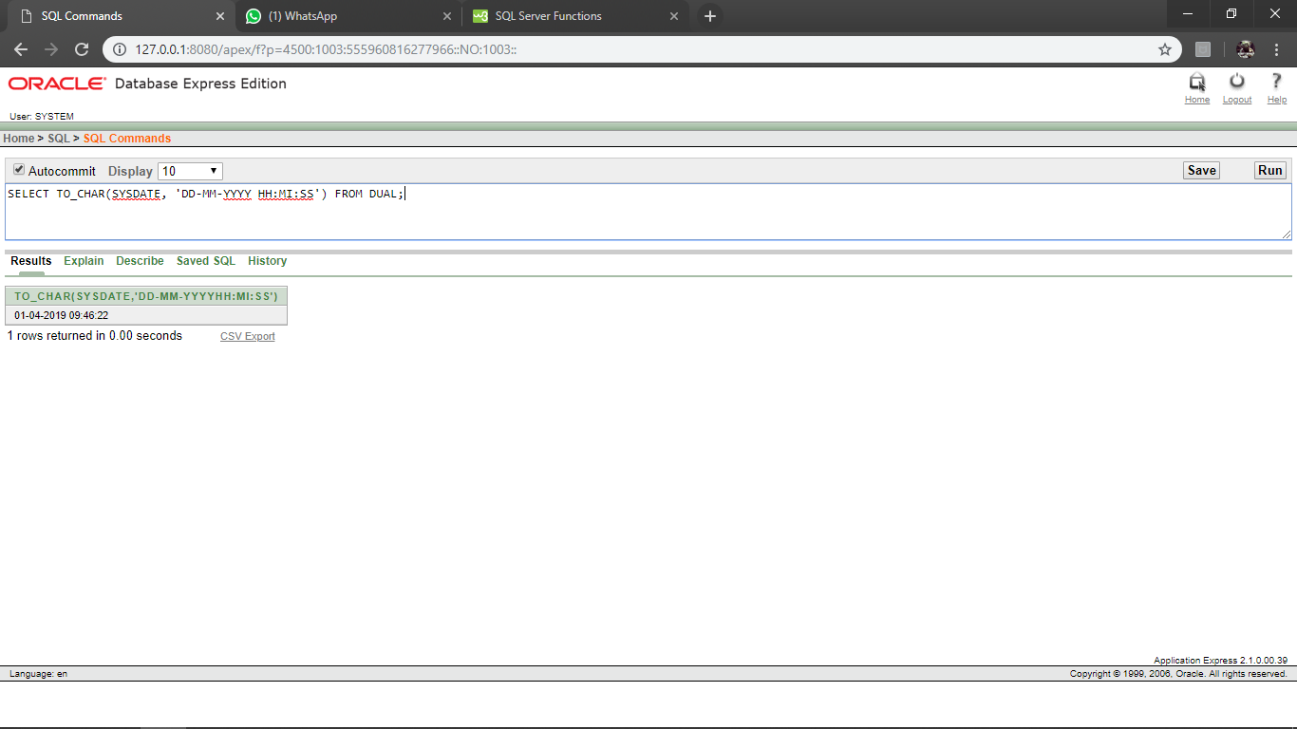

**FINDINGS/LEARNING:**

* String functions like **CONCAT**(), **UPPER**(), **LOWER**(), **SUBSTRING**(),**LENGTH**() are used to perform string operations on tables DEPARTMENT, WARD, DOCTOR, TEST.
* Date functions are used to find out current date and time from system.

**CONCLUSION:**

String and date functions are successfully executed on Hospital Management System

**PROGRAM 5**

**AIM:**

To implement the following SQL joins on given relations

* Inner Join
* Left Outer Join
* Right Outer Join
* Full Outer Join
* Self Join

**THEORY:**

1. **INNER JOIN:** SQL INNER JOINS return all rows from multiple tables where the join condition is met



1. **LEFT OUTER JOIN:** This type of join returns all rows from the LEFT-hand table specified in the ON condition and **only** those rows from the other table where the joined fields are equal (join condition is met)



1. **RIGHT OUTER JOIN:** This type of join returns all rows from the RIGHT-hand table specified in the ON condition and **only** those rows from the other table where the joined fields are equal (join condition is met).



1. **FULL OUTER JOIN:** This type of join returns all rows from the LEFT-hand table and RIGHT-hand table with NULL values in place where the join condition is not met.



1. **SELF JOIN:** A self JOIN is a regular join, but the table is joined with itself.



**DATABASE TABLES:**

1. Customers

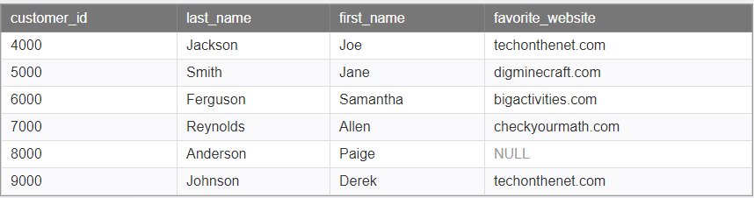

1. Orders

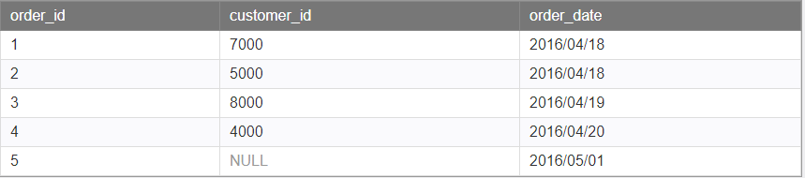

**QUERIES:**

**Right Outer Join**

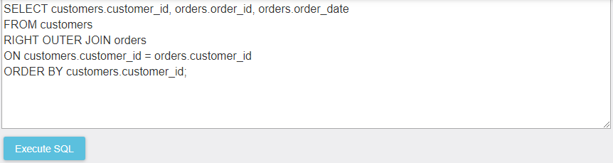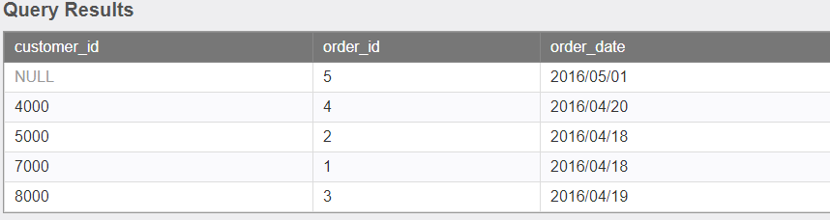

**Left Outer Join**

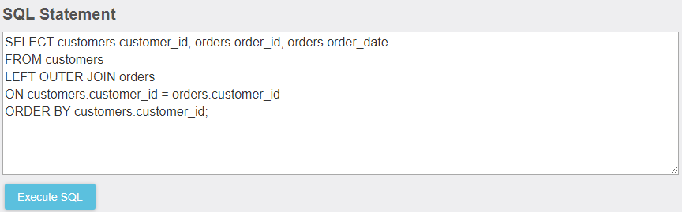

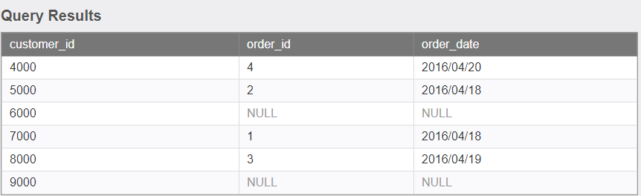

**Inner Join**

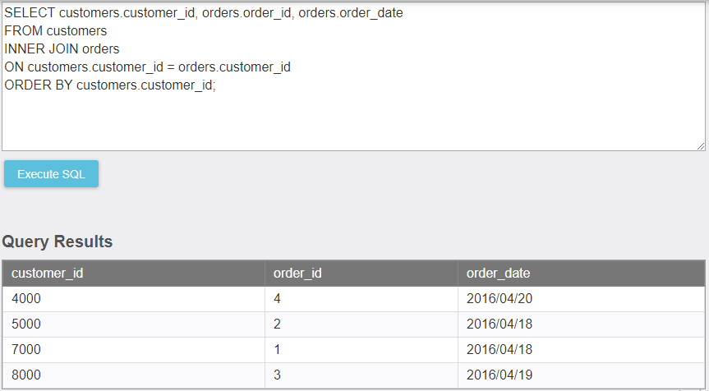

**Full Outer Join**

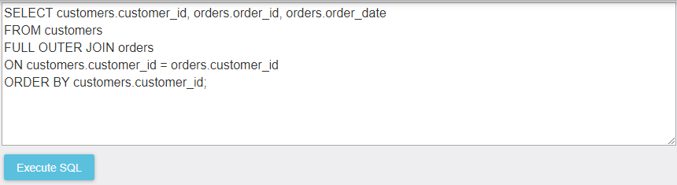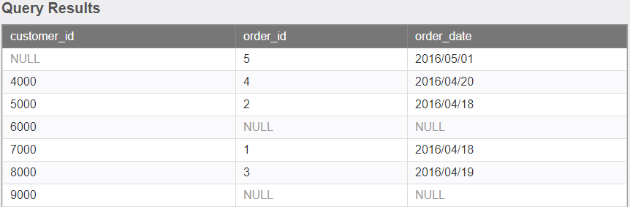

**Self Join**

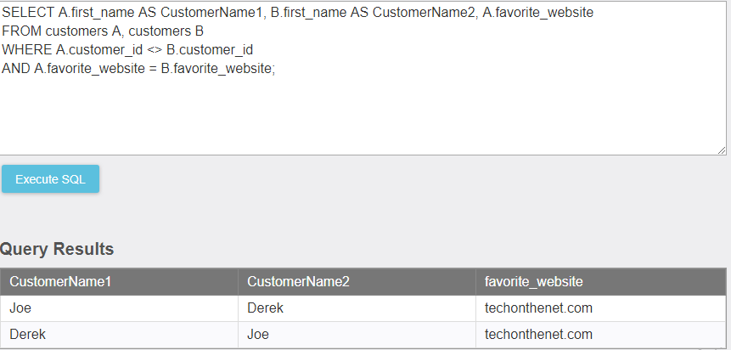

**FINDINGS/LEARNING:**

1. The **INNER JOIN, LEFT OUTER JOIN, RIGHT OUTER JOIN, FULL OUTER JOIN and SELF JOIN** command is used to join values in **CUSTOMERS** and **ORDERS**.

**DISCUSSION:**

SQL JOINS are used to retrieve data from multiple tables. A SQL JOIN is performed whenever two or more tables are listed in a SQL statement.

**CONCLUSION:**

The SQL JOINS are successfully executed on the given relations.